March 4, 2024 GAA Program

DAVID PAUL COOK
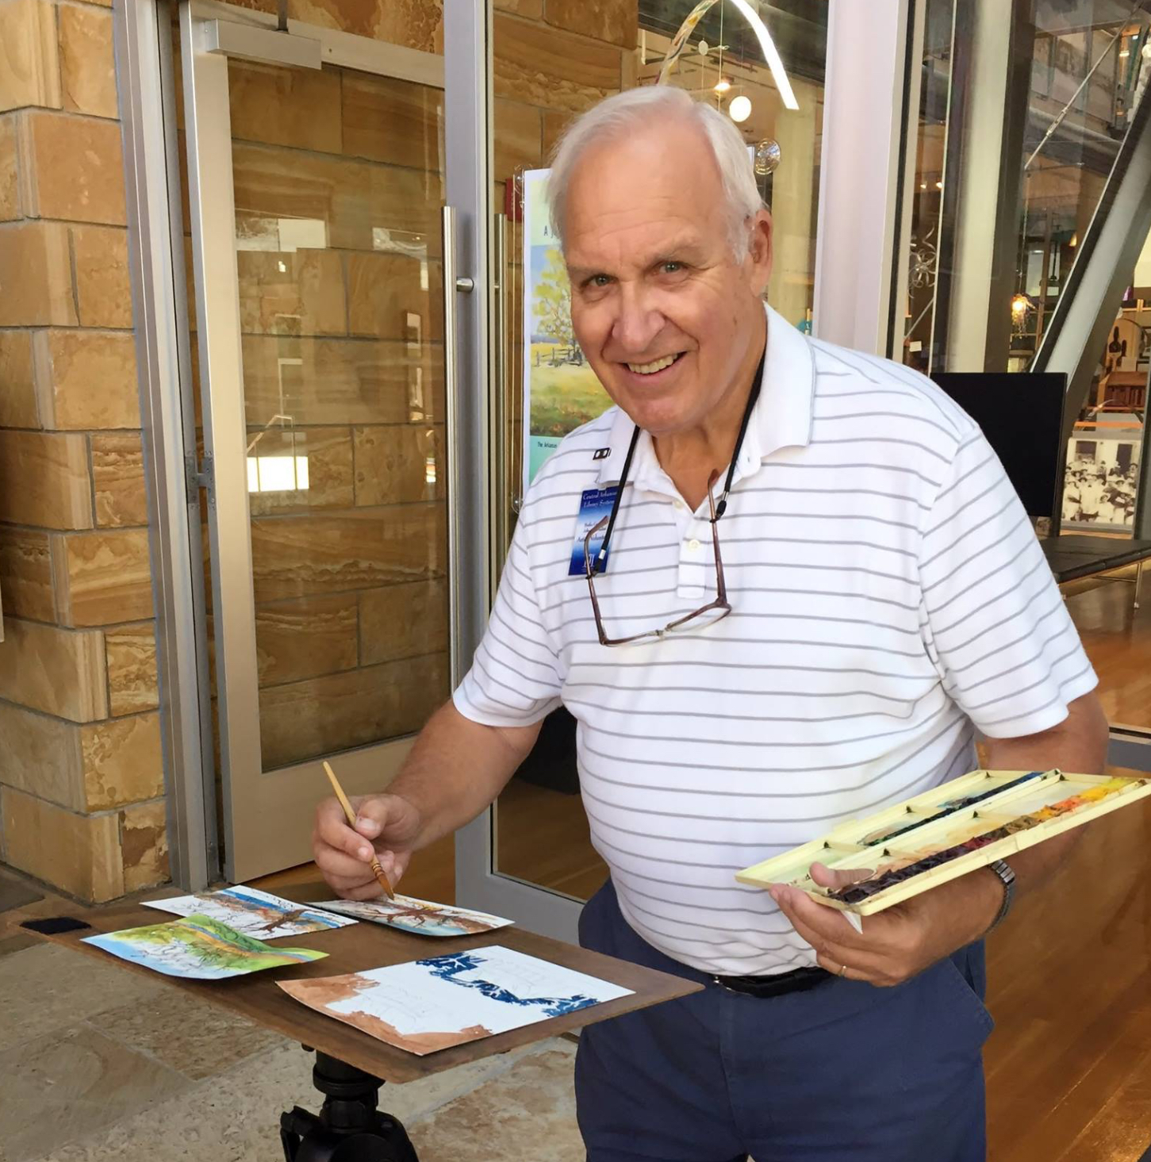
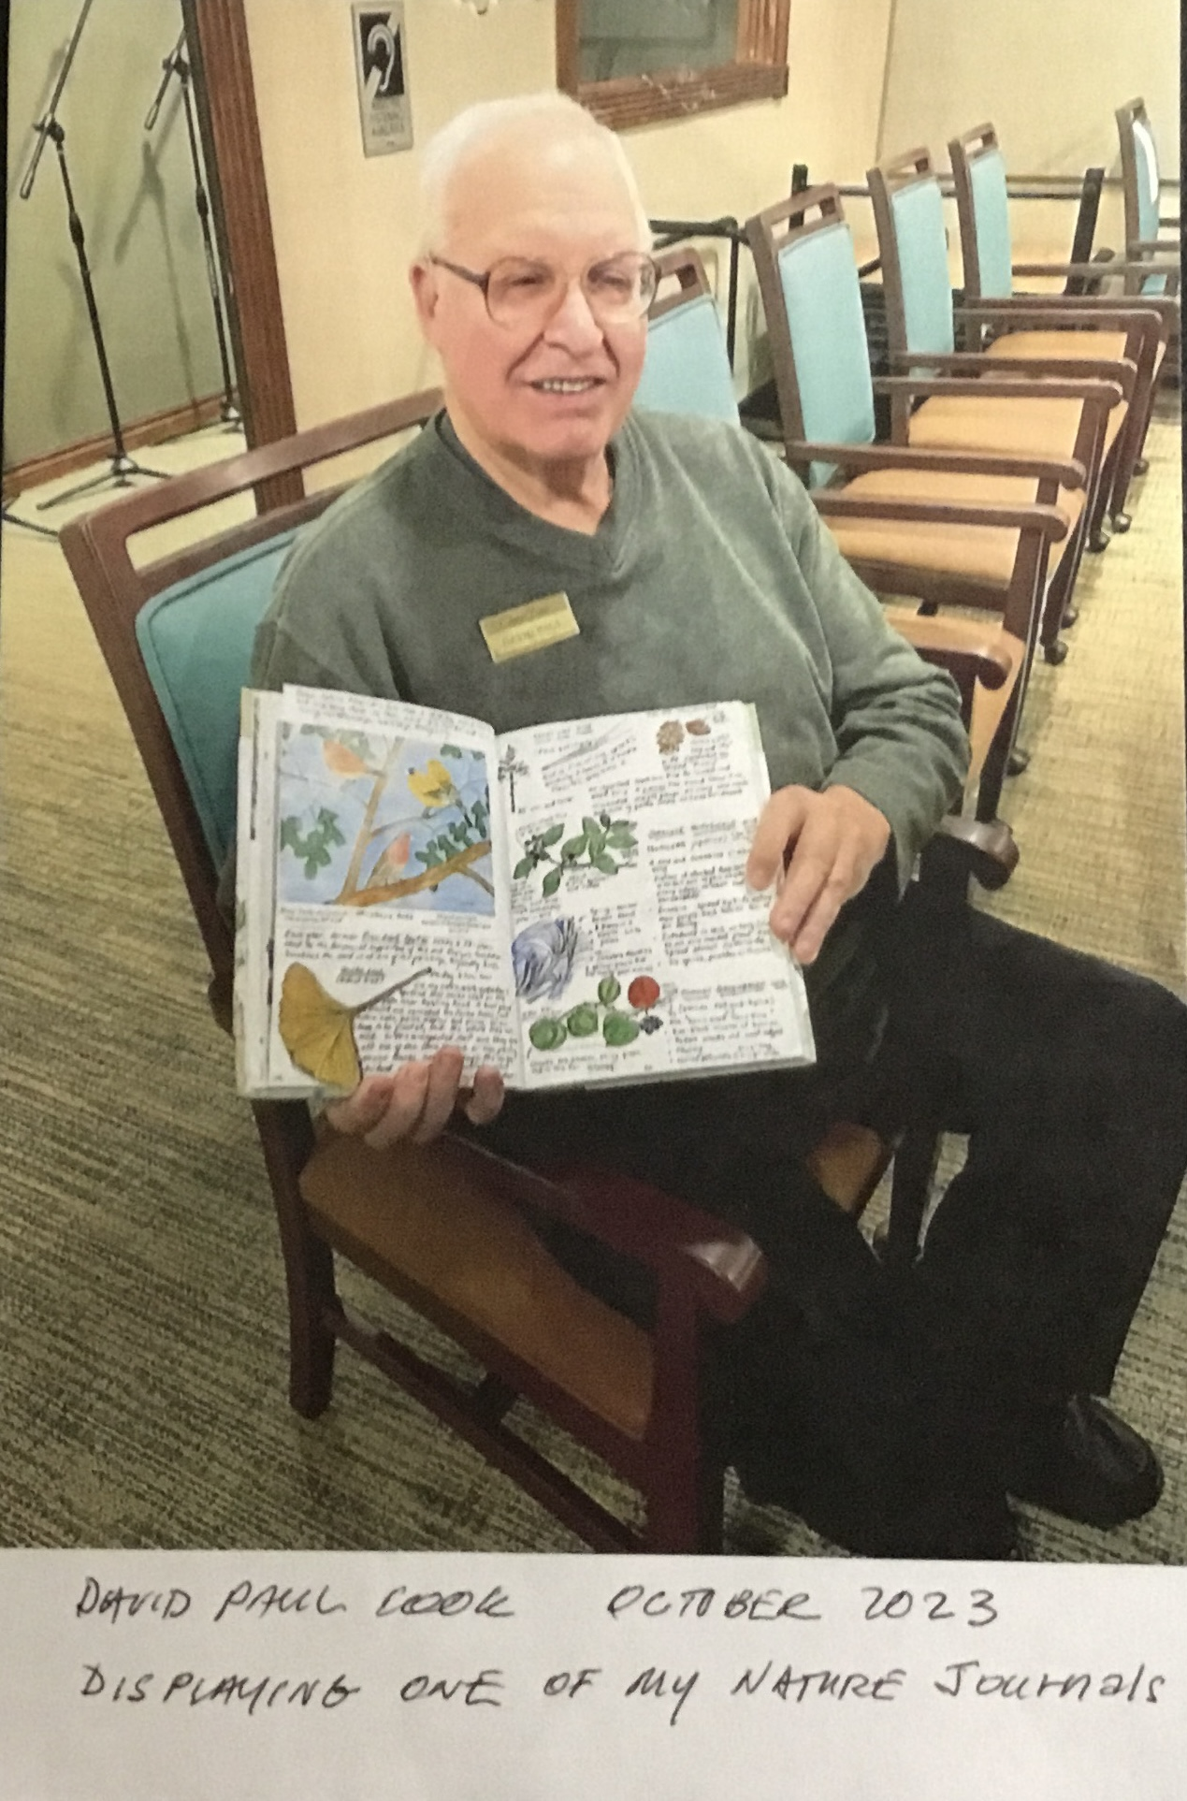
Arkansas artist, David Paul Cook was asked what influences his art, Cook responded "I am influenced by the light and other natural elements, as well as by the sounds, movements, and even smells of each place that I paint, opening all my senses to produce my expression of the scene".
As long as he can remember, David Paul Cook could draw just about anything he laid eyes on. Growing up in Wisconsin, Cook was surrounded by woods, meadows and the abundant array of subject matter offered by nature.
Combining his two loves, art and nature, resulted in his passion for watercolor landscape painting working on location (plein air) to capture the mood and excitement.

